# **Name: Abdurrahman Qureshi**

# **Roll No: 242466**

Assignment No: 2

**Topic:** College Management System Normalization

Normalization in database design ensures that the data is organized efficiently by reducing redundancy and improving data integrity. The following is a step-by-step normalization of a College Management System.

Step 1: Unnormalized Table

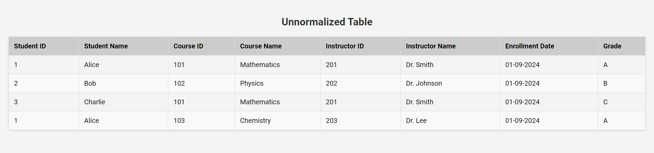

**Step 2: First Normal Form (1NF)**

To display the data in First Normal Form (1NF), we need to ensure that each piece of information is stored in its most atomic form, without repeating groups. In this case, we can create three separate tables to represent the normalized data:

* **Students Table**: Contains information about students.
* **Courses Table**: Contains information about courses.
* **Instructors Table**: Contains information about instructors.
* **Enrollments Table**: Links students to their enrolled courses, showing grades.

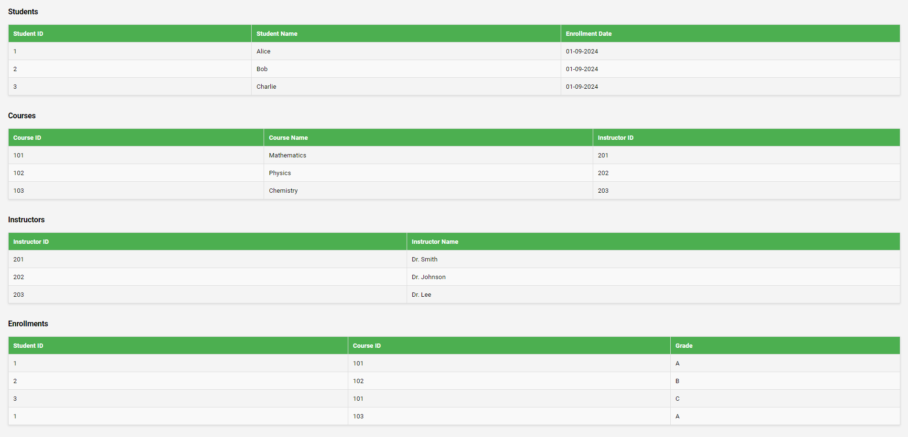

**Step 3: Second Normal Form (2NF)**

To display the data in Second Normal Form (2NF), we must ensure that:

* The table is in First Normal Form (1NF).
* All non-key attributes are fully functionally dependent on the primary key. In this case, we need to separate data into additional tables if there are partial dependencies.
* The **Enrolments** table will reference the **Courses** and **Students** tables through their IDs, making the relationships clear.
* We also separate the instructor information completely from the courses if instructors can teach multiple courses.

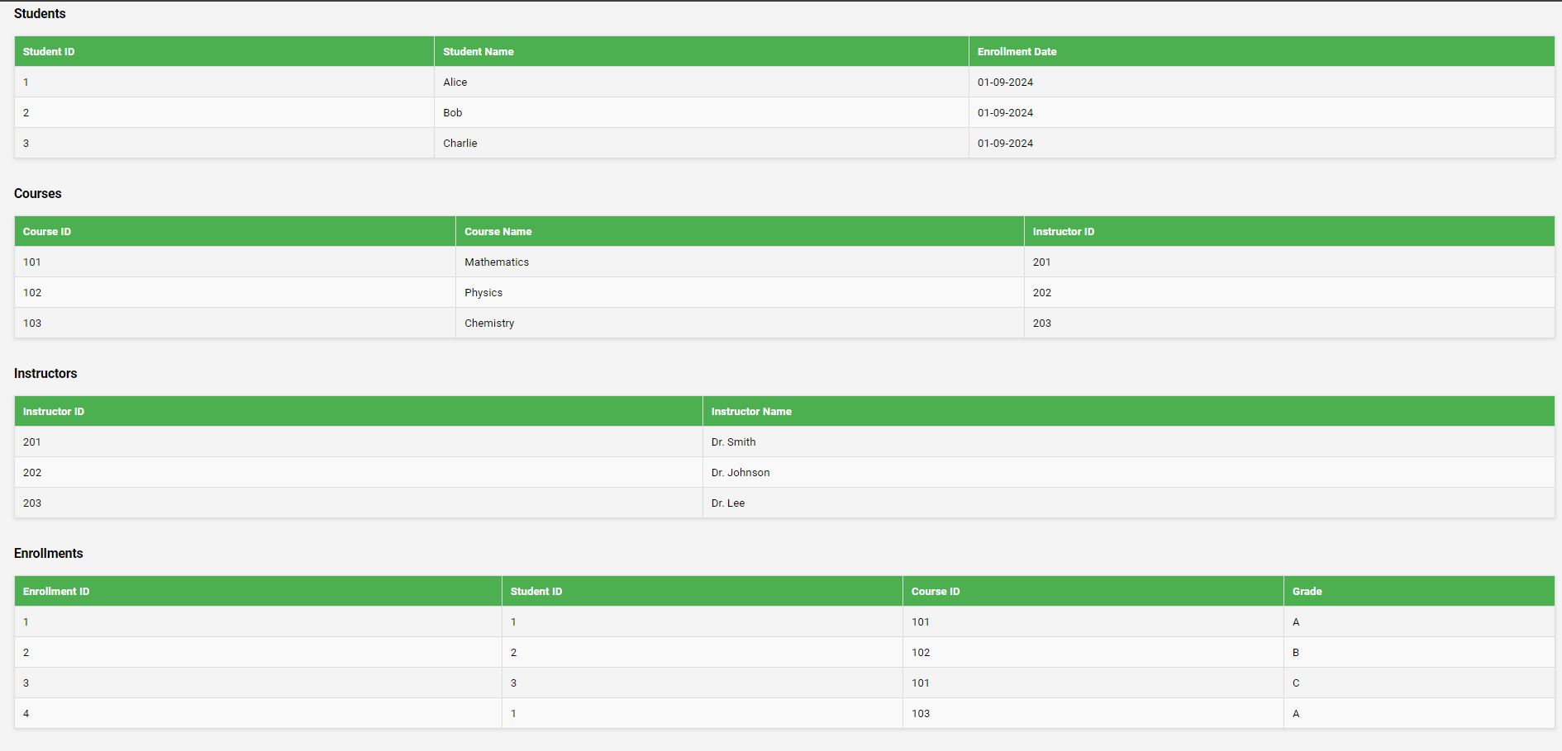

**Step 3: Third Normal Form (3NF)**

To convert the data structure into Third Normal Form (3NF), we need to ensure that:

* The table is in Second Normal Form (2NF).
* All the attributes are functionally dependent only on the primary key, which means no transitive dependencies should exist.

In our case, the **InstructorName** is dependent on **InstructorID**, which is not a part of the primary key in the **Courses** table. Therefore, we need to create a separate **Instructors** table and ensure all related data adheres to 3NF.

* The **Instructors** table is already separate and contains **InstructorID** and **InstructorName**.
* The **Courses** table should only include **CourseID**, **CourseName**, and **InstructorID**.
* The **Students** table remains the same.
* The **Enrollments** table will remain the same but will only refer to IDs from the other tables.

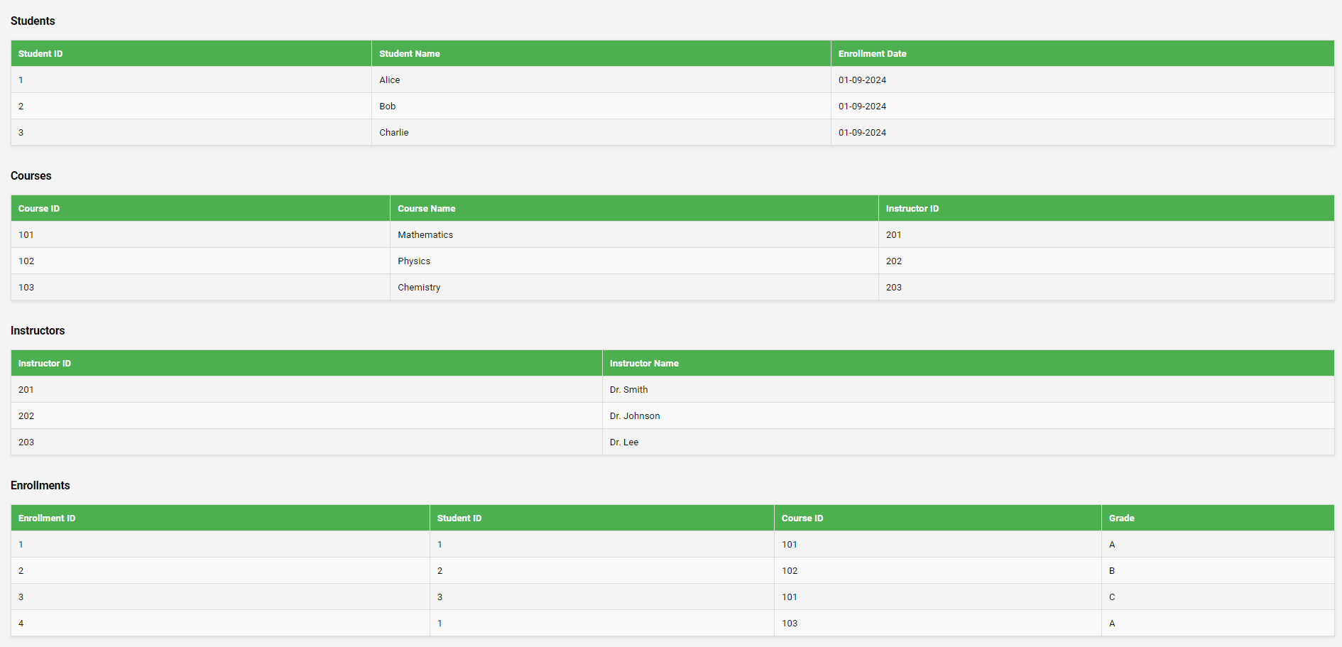

Step 5: Fourth and Fifth Normal Forms (4NF & 5NF)

In the Fourth Normal Form (4NF) and Fifth Normal Form (5NF), we eliminate multi-valued and complex join dependencies, ensuring that our database design adheres to strict normalization principles. At this stage, our tables have reached the final level of normalization, optimizing data integrity and minimizing redundancy.

Conclusion

In this document, we have systematically explored the normalization process of a Library Management System database through various stages, including First Normal Form (1NF), Second Normal Form (2NF), Third Normal Form (3NF), Fourth Normal Form (4NF), and Fifth Normal Form (5NF). By applying these normalization techniques, we have effectively reduced data redundancy, enhanced data integrity, and organized the information into efficient and meaningful tables. This structured approach ensures that the database is optimized for storage, retrieval, and maintenance, thereby mitigating potential anomalies and inconsistencies that often arise from poorly structured databases.